03.12.1 — Component architecture

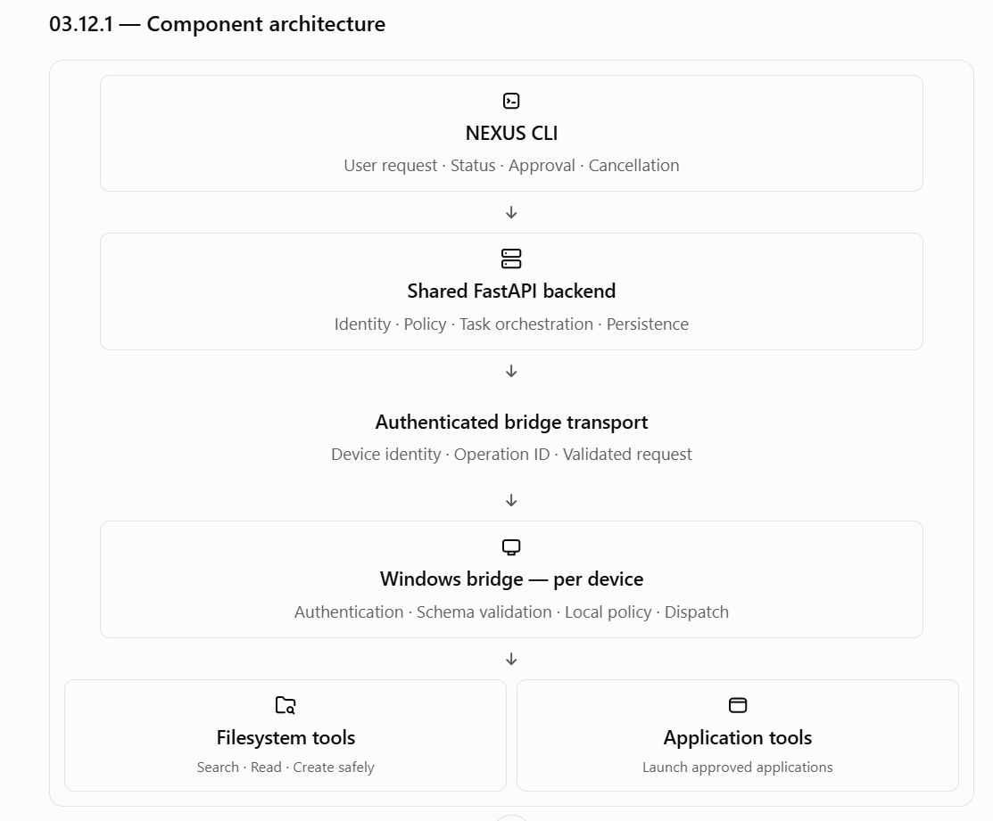Responsibility boundaries
Component | Owns
CLI | User interaction and presentation
Backend | Identity, authorization, task state, approval and orchestration
Bridge transport | Authenticated delivery and response correlation
Windows bridge | Local execution constraints and tool invocation
Individual tool handler | Operation-specific validation, execution and verification
The bridge must not independently invent a task plan or elevate permissions. It receives a specific operation, validates it and either executes it or returns a structured rejection.

03.12.2 — Bridge process and lifecycle
Each teammate runs their own Windows bridge. A bridge must have a defined lifecycle rather than behaving as an unmanaged background script.

Proposed lifecycle
- Start the bridge under the intended Windows user account.
- Load non-secret configuration and retrieve credentials from protected storage.
- Authenticate to the configured NEXUS backend.
- Register or verify the device identity.
- Report bridge readiness and supported tool capabilities.
- Accept only authenticated operations addressed to that device.
- Validate each operation and dispatch it to a registered handler.
- Report results and persist enough local operation metadata for safe reconciliation.
- On disconnect, stop accepting new work that requires backend authorization.
- On shutdown, stop dispatching new work and report the state of in-flight operations where possible.
The bridge should expose a clear local health status, such as starting, connected, disconnected, degraded or stopping. These are proposed labels; the final health-state contract belongs in the operations section.
Important Windows constraint: a process running in WSL2 is not equivalent to a process running in the Windows user session. NEXUS should implement Windows-specific tools in a native Windows-side process, even though the shared backend and most development work run in Ubuntu on WSL2.
This is especially important for user-specific paths, Windows application launching, credential storage and any future interactive desktop capabilities.

03.12.3 — Initial tool registry
NEXUS should launch with a deliberately small set of tools that are easy to validate, test and secure.
A tool is a defined capability with a stable name, a schema, permission requirements, a risk classification, execution limits and a result contract. It is not an arbitrary command generated by the model.

Proposed MVP tools

1. search_files
Tier 0
Search within a configured directory scope using a filename query and explicitly supported filters.
Must enforce scope boundaries, limit results and handle inaccessible folders without exposing unrelated filesystem details.

2. read_document
Tier 0
Read supported document formats from permitted directories and return bounded content or a safe extraction summary.
Initial formats should be explicitly selected and tested; do not promise arbitrary document compatibility.

3. create_file
Tier 1
Create a new file with supplied content inside an approved output directory.
Default to create-only behavior. If the destination exists, fail without overwriting unless a separate, explicitly authorized workflow supports it.

4. launch_application
Tier 1
Launch an application from a locally configured allowlist.
Use a registered application identifier rather than allowing the model to submit an arbitrary executable path or command line.
These are the proposed first four tools, not a final commitment to every file format or application. Full GUI automation, unrestricted mouse/keyboard control, arbitrary shell execution and administrative actions remain outside the initial tool set.

Tool registry metadata
Each registered tool should declare at least:
Field | Purpose
tool_name | Stable identifier
schema_version | Version of the input/output contract
description | Intended capability
input_schema | Allowed parameters and validation rules
output_schema | Structured result format
risk_tier | Default risk classification
required_permissions | Required capability grants
timeout_policy | Execution deadline
retry_policy | Whether and how the operation can be retried
enabled | Whether this tool is currently available
The registry is maintained by application code. A model may select from the tools it is offered, but it cannot register a new tool, change its risk tier or weaken its permissions.

03.12.4 — Structured operation contract
Backend and bridge communication should use structured messages rather than free-form instructions.
An illustrative operation request:
{
"protocol_version": "1",
"operation_id": "op-123",
"task_id": "task-456",
"target_device_id": "device-123",
"tool_name": "search_files",
"schema_version": "1",
"arguments": {
"directory_id": "project_documents",
"query": "design",
"max_results": 20
},
"deadline": "example-deadline"
}
This is a conceptual example. The deadline representation, identifiers, transport envelope and complete schema have not yet been finalized.

Required validation
Before dispatch, the backend must validate the proposed operation against the registered tool schema and applicable policy.
On receipt, the bridge must independently validate:
- Protocol and schema versions.
- Device identity and target.
- Operation identifier and duplicate status.
- Tool name and enabled status.
- Required and unexpected arguments.
- Argument types, lengths and permitted values.
- Local directory and application restrictions.
- Relevant deadlines and resource limits.
Unknown fields should be rejected or handled according to a documented versioning policy; they must not silently change behavior.

Structured response contract
The bridge should return a machine-readable result with fields conceptually equivalent to:
{
"operation_id": "op-123",
"device_id": "device-123",
"status": "succeeded",
"result": {
"items": [],
"truncated": false
},
"error": null
}
The exact result structure depends on the tool. A file search returns matching file metadata; a file creation operation returns the created file's verified location and relevant outcome information.
A response should distinguish at least:
- Succeeded: the operation completed and its result is known.
- Failed: the operation failed and the failure is known.
- Rejected: the bridge refused the operation before executing it.
- Uncertain: execution may have occurred, but the outcome cannot be established.
A transport timeout is not equivalent to a tool failure. If the bridge stops responding after receiving an operation, the backend must not infer that nothing happened.

03.12.5 — Safe filesystem access
Filesystem operations are among the highest-value MVP capabilities, but they must be constrained carefully.

Directory identifiers, not unrestricted paths
The backend and model should work with logical directory identifiers, such as project_documents, rather than freely choosing absolute Windows paths.
The bridge maintains the local mapping:
Logical identifier | Local configuration
project_documents | A user-approved project directory
nexus_workspace | A dedicated NEXUS working directory
approved_output_directory | A user-approved output location
These are example identifiers. Actual locations must be configured on each computer, not copied from one teammate's machine to another.
The backend should not need to know a teammate's entire filesystem layout. It can ask the bridge to use a registered directory scope.

Path-safety requirements
The implementation must account for:
- .. path traversal.
- Absolute paths supplied where only a relative path is allowed.
- Windows drive-letter and UNC paths.
- Symbolic links and Windows reparse points.
- Case-insensitive path comparisons.
- Reserved filenames and invalid characters.
- File changes between validation and use.
- File size and content-length limits.
- Permission failures and locked files.
- Existing destinations and overwrite behavior.
Checking whether a path string starts with an allowed directory string is not sufficient. The bridge needs safe path resolution and operation-specific checks against the actual target.

search_files contract
Proposed input:
Field | Type | Constraint
directory_id | String | Must reference an approved local scope
query | String | Bounded length; treated as a search term, not executable code
max_results | Integer | Bounded by a server-defined maximum
Proposed output includes a list of matching entries, bounded metadata and a truncated flag if additional matches were omitted.
The search should not recursively inspect the entire drive by default. Search depth, hidden/system files, file types, exclusions and symlink behavior must be specified.

read_document contract
Proposed input:
- Logical directory identifier.
- A path or file reference resolved within that scope.
- Optional extraction settings chosen from an allowlist.
Proposed output:
- Document metadata.
- Extracted text or a bounded representation.
- Whether content was truncated.
- Any extraction warning or unsupported-format error.
Document parsing should be isolated from authorization. Being able to parse a PDF does not imply permission to read every PDF on the computer.
The first supported format set should be small enough to test properly. PDF, DOCX and plain text are plausible candidates, but the team should confirm library availability, extraction quality and resource usage before finalizing the set.

create_file contract
Proposed input:
- Approved output directory identifier.
- Validated relative filename.
- Content.
- Optional explicitly supported content type.
Required behavior:
- Validate the output directory and filename.
- Enforce content-size limits.
- Reject path traversal and unsafe targets.
- Apply create-only semantics by default.
- Avoid silently overwriting an existing file.
- Verify that the new file was created as intended.
- Return the outcome and operation identifier.
For safer creation, the implementation should use an atomic create-if-absent mechanism where supported, rather than a separate existence check followed by a write that another process can race.
If a failure occurs after a file may have been created, return an uncertain outcome when the actual state cannot be established. Do not automatically delete or overwrite the file in an attempt to hide the uncertainty.

03.12.6 — Application launching
Application launching should use a locally configured allowlist.
For example, the local bridge configuration might map a logical identifier such as text_editor to an approved executable. The model selects text_editor; it does not decide which arbitrary executable should run.
The final contract must define:
- Which applications are allowed.
- Whether arguments are supported for each application.
- Which argument values are permitted.
- How process launch success is determined.
- Whether an already-running application is reused or another instance is launched.
- What timeout means for a process that continues running.
- How the bridge reports a launch that succeeded but whose response was lost.
Avoid passing user-provided strings to a shell for interpretation. If an application supports arguments, invoke it using a controlled process API with a validated argument list.
Launching an application is not the same as completing an action inside that application. For example, launching a text editor does not prove that a document was saved. NEXUS must report only what it can verify.

03.12.7 — Timeouts, cancellation and duplicate operations
Each tool needs a defined timeout and retry policy. A single global timeout is unlikely to fit both a fast filename search and a large document extraction.

Proposed behavior
- Timeout before dispatch: do not execute the operation.
- Timeout while waiting for the bridge: report that the operation outcome is unknown until reconciled.
- Cancellation before dispatch: do not dispatch the operation.
- Cancellation after dispatch: signal cancellation where supported and determine whether the operation already completed.
- Duplicate operation ID: return the recorded outcome if known; otherwise return the operation's current state.
- Unknown operation ID: validate the request normally; do not assume it is a retry.
- Expired operation: reject execution if it has not started, subject to the agreed deadline semantics.

Operation deduplication
The bridge needs a durable record of operation identifiers if it is expected to survive process restarts without blindly repeating previous work.
At minimum, the bridge-side record should allow it to distinguish:
- An operation never received.
- An operation accepted but not started.
- An operation currently executing.
- An operation with a known result.
- An operation whose outcome is uncertain.
The storage mechanism is still open. A small local SQLite database is a candidate, but its value depends on the bridge's expected durability requirements and the complexity it introduces. An in-memory cache alone is insufficient if duplicate protection must survive bridge restarts.
A key rule is that deduplication must be paired with reconciliation. Remembering an operation ID without recording enough state to establish the outcome does not solve the uncertainty problem.

03.12.8 — Bridge transport and connectivity
The bridge communication pattern is still undecided. Two options deserve evaluation.
Option A — Bridge polls the backend
Initial candidate
The bridge periodically asks the backend for authorized work, then submits results.
Advantages: simpler inbound networking, works naturally when the bridge initiates connections, and fits a LAN environment with Windows Firewall restrictions.
Trade-offs: polling introduces latency and repeated requests; long polling or another notification mechanism may eventually be useful.
Option B — Backend pushes work to the bridge
The backend maintains a connection to the bridge or sends work over an established channel.
Advantages: potentially faster task delivery and less polling overhead.
Trade-offs: connection management, reconnect behavior, authentication, message delivery and duplicate handling become more complex. Backend-initiated connectivity can also be difficult across host and WSL2 networking boundaries.
Provisional recommendation: begin by evaluating authenticated bridge polling over HTTP. It avoids requiring the backend to initiate a new inbound connection to each teammate's computer. The actual choice must be validated in the intended WSL2 and Windows Firewall setup.
Regardless of transport:
- Every message must identify the target device and operation.
- Requests must be authenticated and authorized.
- The bridge must reconnect safely after network interruption.
- Reconnection must not trigger blind replay of previously dispatched operations.
- The protocol must support timeouts, bounded payloads, versioning and structured errors.
- A device must not accept operations addressed to another device.
The protocol's exact polling interval, request timeout, heartbeat interval and authentication mechanism remain open.

03.12.9 — Local state and persistence
The backend's PostgreSQL database remains the authoritative source for task ownership, approvals and overall task state.
The bridge may still need local persistence for:
- Device configuration and identity.
- Operation deduplication records.
- Recent operation outcomes.
- Diagnostic information needed for reconciliation.
- Local capability and directory configuration.
A small local database is one possible implementation. Configuration files may also be suitable for non-secret settings. Credentials should use protected storage appropriate to Windows.
The bridge's local state must not be treated as authority to override backend permissions. If the backend is unavailable, the bridge should not accept new operations that require a fresh backend authorization decision.

Restart recovery
After a bridge restarts:
- Load its registered device identity and safe local configuration.
- Authenticate to the backend.
- Report any operations that were in progress at shutdown.
- Reconcile those operations against local state where possible.
- Resume only operations that are safe and still authorized.
- Leave uncertain operations in a recovery state rather than replaying them blindly.
The team must define how long local operation records are retained and what happens when a record is missing or corrupted.

03.12.10 — Bridge observability
The bridge needs enough diagnostic information to explain failures without collecting unnecessary private data.
Proposed operational fields include:
- Device ID.
- Operation ID and task ID.
- Tool name and schema version.
- Start and end timestamps.
- Execution duration.
- Outcome category.
- Error code.
- Retry or reconciliation status.
- Bridge health and connectivity state.
Do not log full document contents, credentials or arbitrary file data by default.
The bridge should expose a health report to the backend that distinguishes connectivity from actual tool readiness. A successful heartbeat means the bridge is reachable; it does not prove that every application is installed or every directory is accessible.

03.12.11 — Bridge acceptance tests

Bridge implementation review
0/22
Protocol and identity
Only authenticated operations for the registered device are accepted.
Unknown tools, malformed inputs and unsupported schema versions are rejected safely.
A bridge cannot impersonate another device using only its device ID.
Payload and execution limits are enforced.
Filesystem safety
Search and read stay within configured directory scopes.
Path traversal and unsafe path forms are rejected.
A create-only operation never silently overwrites an existing file.
Concurrent attempts to create the same destination are handled safely.
Document size and extraction limits are enforced.
Execution and recovery
Duplicate operation IDs do not blindly repeat completed work.
An uncertain file operation is reconciled before an unsafe retry.
Bridge restart preserves sufficient operation state for recovery.
Cancellation reports the real outcome of any in-flight operation.
A disconnected bridge cannot silently redirect work to another computer.
Applications and operations
Only allowlisted applications can be launched.
Application arguments are validated without unsafe shell interpretation.
A successful launch is not reported as successful completion of a later application task.
Timeouts, permission errors and unsupported operations return stable error categories.
Privacy and deployment
Credentials are not stored in plaintext configuration or source control.
Logs do not contain unnecessary private document content.
The bridge runs without unnecessary administrator privileges.
Every teammate can register, start, disconnect and reconnect their own bridge.

03.12.12 — Decisions still open
Before the bridge contract is frozen, the team must settle:
- Bridge transport: polling, long polling or a persistent connection.
- Bridge authentication and credential rotation.
- Local persistence mechanism for operation deduplication and recovery.
- Initial document formats and maximum supported sizes.
- Exact directory-scoping and path-resolution behavior.
- Approved application list and whether application arguments are supported.
- Timeout and retry policy for each tool.
- How operation results are reconciled after a lost response.
- Bridge installation, configuration and startup behavior for all three teammates.
- Whether the MVP needs interactive desktop automation or can deliver its initial value through filesystem and application tools alone.

